AP EURO REVIEW TOPICS/SHORT ANSWER QUESTIONS
- Renaissance and New Monarchies
Using your knowledge of European history, answer parts A, B, and C below.
Historians have proposed various humanists as most representative of the Renaissance period.
- Choose the thinker you think is most important and briefly explain why.
- Provide at least ONE piece of evidence that supports your explanation.
- Choose another humanist who is less significant and briefly explain why that person is not as important as the person you identified in part A.

- Reformation and the Religious Wars of the 16th Century
The Protestant Reformation led to multiple Christian faiths throughout Western Europe. There were many significant individuals who contributed including Desiderius Erasmus, Martin Luther, and John Calvin.
- Briefly explain why ONE of the individuals on the list contributed most to this era of religious reform.
- Provide at least ONE piece of evidence to support your explanation.
- Briefly explain why ONE of the other individuals was less significant than the one you chose in part A.

- Europe’s New Encounters in the Americas
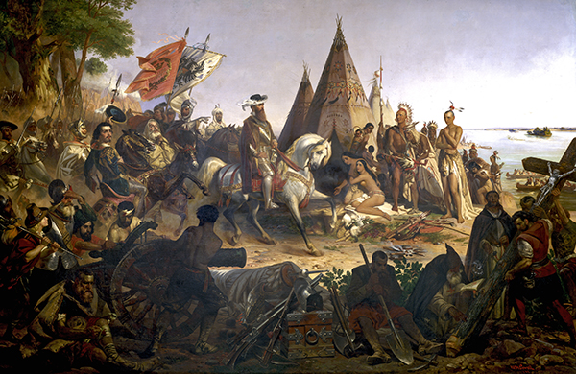
William Henry Powell, Discover of the Mississippi, 1853
- Briefly explain ideas expressed in this painting regarding the Spanish conquest of the New World about one of the following: RELIGION, MILITARY SUPERIORITY, WEALTH
- Briefly explain ONE way in which lives of Native Americans were changed as a result of the Spanish conquest.
- Briefly explain ONE way in which the Spanish conquest of the New World impacted Europeans.

- Absolute Monarchs/Glorious Revolution
Using your knowledge of European history, answer parts A, B, and C below.
- Briefly explain ONE important similarity between the reign of Louis XIV in France and the reign of Peter the Great in Russia.
- Briefly explain ONE important difference between the reign of Louis XIV in France and the reign of Peter the Great in Russia.
- Briefly analyze one factor that accounts for the difference you identified in part B.

- Scientific Revolution
Using your knowledge of European history, answer parts A, B, and C below.
- Briefly explain ONE example of how new ideas in science challenged traditional views of the cosmos, nature, or the human body.
- Briefly explain a SECOND example of how new ideas in science challenged traditional views of the cosmos, nature, or the human body.
- Briefly explain ONE example of the persistence of traditional views of the cosmos, nature, or the human body.

- Enlightenment
Using your knowledge of European history, answer parts A, B, and C below.
- Briefly explain ONE important similarity in the ideas of John Locke and Adam Smith.
- Briefly explain ONE important difference in the ideas of John Locke and Adam Smith.
- Briefly explain ONE factor that accounts for the similarity you identified in part A.

- Enlightened Despots/New Economies

"She turned a blind eye to the presence and activities of the Old Believers, wound down Orthodox missionary activity among Muslims and pagans and allowed 'reputable' religions to build churches, run their own schools and practice their religion freely though under state inspection of their organisation and finances....
Catherine herself was opposed to serfdom and she took some steps to introduce non-servile tenures on imperial estates which proved highly unpopular with the serfs....She had, for instance, suggested that serfs should be entitled to purchase their freedom, or that servitude should be entitled to purchase their freedom, or that servitude should be limited to a period of six years....Historians have also criticized her for giving away thousands of 'free' peasants to her favourites and public servants, thus ensuring them....
What marks Catherine's approach is the careful planning of a programme of interrelated measures steadily pursued over a number of years. Local government and the judiciary were remodeled in 1775 with elected participation by nobles, townspeople and state peasants."
-Isabel Madariaga, historian, "Catherine the Great: A Personal View," 2001
A) Briefly explain ONE piece of evidence that Madariaga uses in the excerpt that supports the idea of Catherine the Great as an enlightened absolute ruler.
B) Briefly explain ONE piece of evidence that Madariaga uses in the excerpt that refutes the idea that Catherine the Great was an enlightened absolute ruler.
C) Briefly explain ONE way not mentioned in the excerpt in which Catherine sought to westernize the Russian state and society.

- French Revolution and Napoleon
Historians have portrayed Napoleon Bonaparte as both an enlightened reformer and a tyrant. Using your knowledge of European history, answer parts A and B.
- Briefly explain TWO pieces of evidence supporting the idea that Napoleon was an enlightened ruler.
- Briefly explain ONE piece of evidence that supports the idea Napoleon was a tyrant.

- Industrial Revolution/Urbanization/Social Changes
Using your knowledge of European history, answer parts A, B, and C below.
- Briefly explain ONE way in which the industrialization of the continent was different from industrialization of Great Britain.
- Briefly explain a SECOND way in which the industrialization of the continent was different from industrialization of Great Britain.
- Briefly explain ONE reason that accounted for the lack of industry in eastern and southern Europe.

- Conservative Order/Revolutions/Romanticism
Using your knowledge of European history, answer parts A, B, and C below.
Historians have proposed that both the Peace of Westphalia and the Concert of Europe were important turning points that influenced the diplomacy of the European States.
- Briefly explain ONE way in which the Peace of Westphalia was a turning point that influenced the diplomacy of the European states.
- Briefly explain ONE way in which the Concert of Europe was a turning point that influenced the diplomacy of the European states.
- Briefly explain ONE important difference between the Peace of Westphalia and the Concert of Europe.

- Age of Nationalism/Realism
Using your knowledge of European history, answer parts A, B, and C below.
Many historians contend that Otto von Bismarck epitomized the idea of Realpolitik.
- Briefly explain ONE way in which Bismarck practiced Realpolitik.
- Briefly explain how ONE other European leader of this era used Realpolitik.
- Briefly explain how Realpolitik was successful or unsuccessful for the countries identified in A and B.

- Age of Progress/Mass Society
Using your knowledge of European history, answer parts A, B, and C below.
Over time, urbanization changed drastically since the first Industrial Revolution.
- Briefly explain TWO ways in which urbanization improved the quality of life with specific evidence.
- Briefly explain ONE way in which urbanization did not improve the quality of life.

- Age of Modernity, Anxiety, and Imperialism
Using your knowledge of European history, answer parts A, B, and C below.
- Briefly explain ONE important similarity between the factors that led to the “new imperialism” of the late 19th and early 20th centuries and the factors that led to the “Age of Exploration and Discovery” of the 15th through 17th centuries.
- Briefly explain ONE important difference between the factors that led to the “new imperialism” of the late 19th and early 20th centuries and the factors that led to the “Age of Exploration and Discovery” of the 15th through 17th centuries.
- Briefly analyze ONE factor that accounts for the difference you identified in part B.

